**Custom Font**

# Dependency Required

The dependency required to support Jasper report:

<dependency>

<groupId>net.sf.jasperreports</groupId>

<artifactId>jasperreports</artifactId>

<version>6.21.0</version>

</dependency>

To support Custom font:  
  
 <dependency>

<groupId>net.sf.jasperreports</groupId>

<artifactId>jasperreports-fonts</artifactId>

<version>6.21.0</version>

</dependency>

# Basic Setup

## Create the Jrxml file with your desire design

Create your own design but make sure to Choose a Bengali font. For this time, I use Kalpurush font.

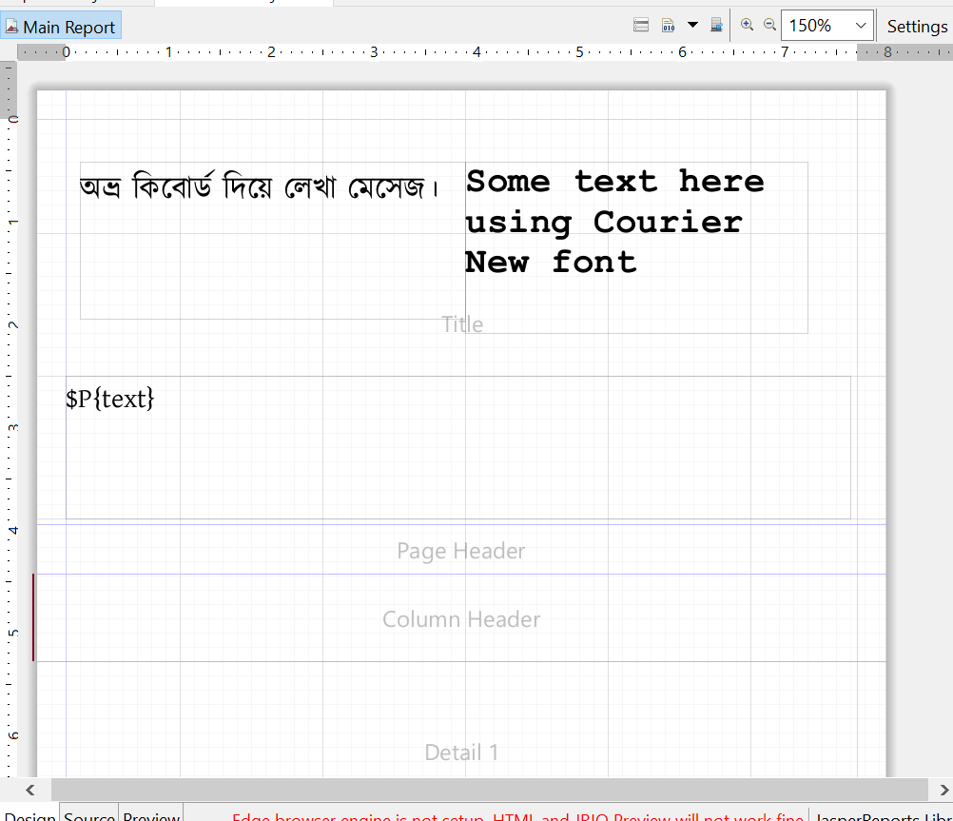

Make sure to select PDF Encoding type Identity-H for Bengali inputs

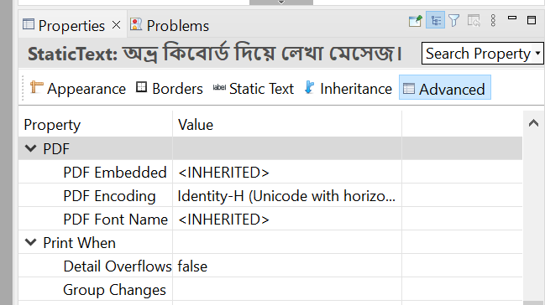

## Create appropriate controller and service class to load the jrxml file

Service Class which typically returning byte.

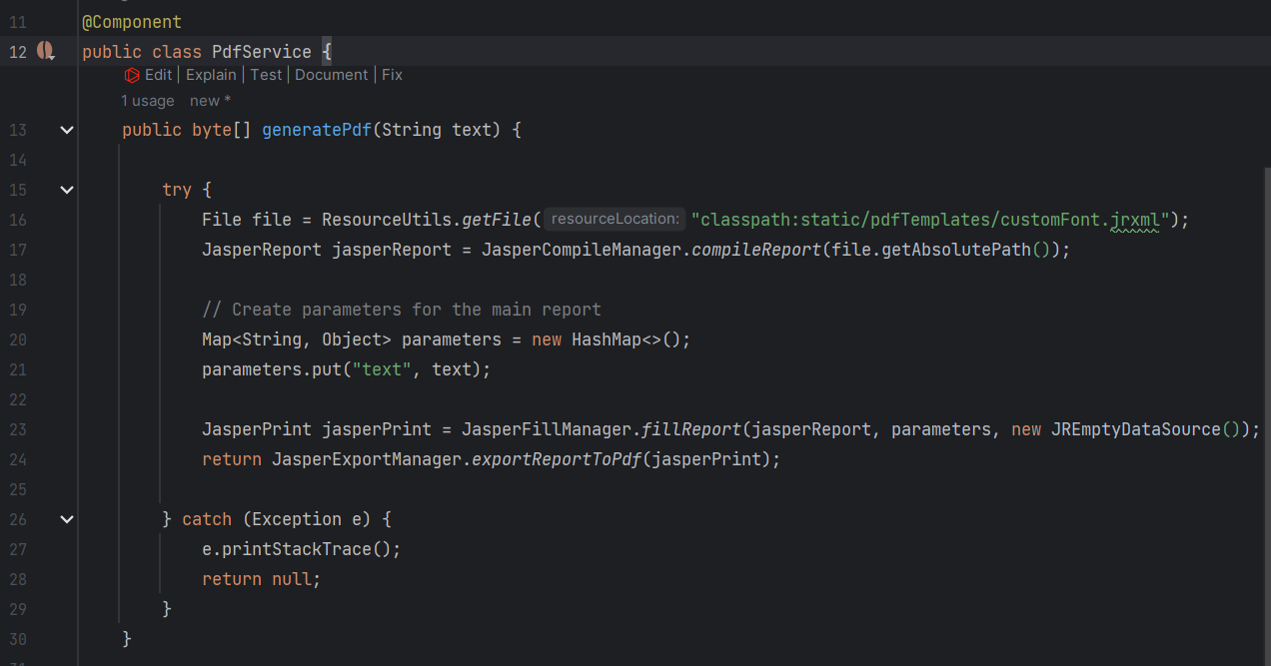

Controller Class to hit the service class and generate PDF

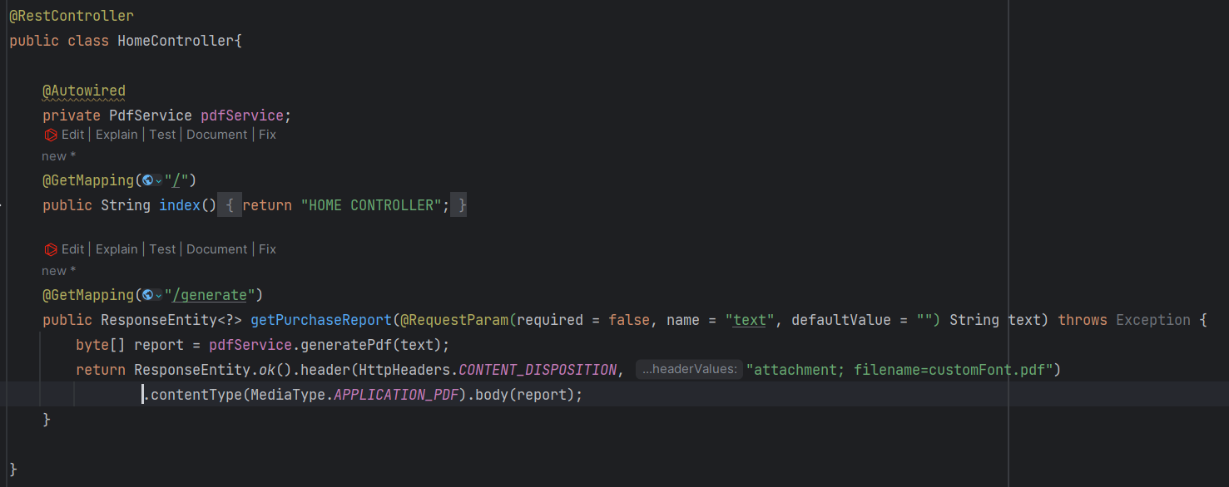

## Write configuration to support Custom Font (WAY: 1)

In the resource folder, you need to create a properties file. The file name should be “jasperreports_extension.properties”

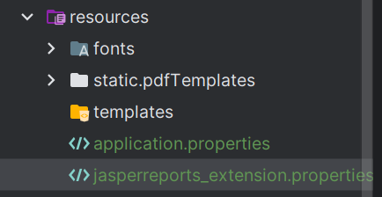

Inside the file paste this code:  


Here, in the second line you have to define the fontfamily.xml file path. This xml contains meta data of the fonts, typically used to say the program “The font file (TTF) location is there”.